# Overview

All development work will be carried out on branch until it’s reviewed.

Regression test on trunk is only required when

* Major task is completed and merged to trunk, or
* Accumulated a number of small changes (e.g. weekly, or over 5 small changes).

# Process

## Create branch

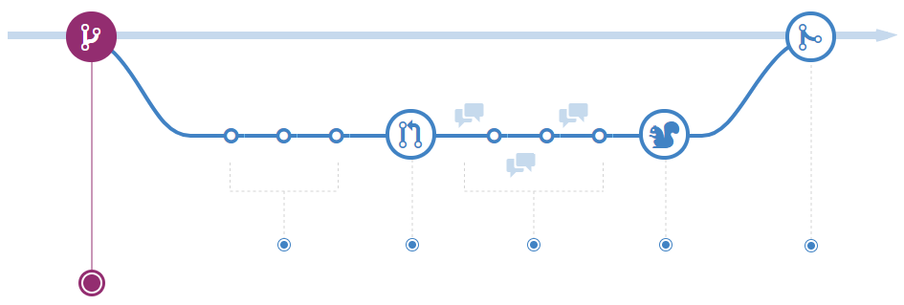

* Create a branch for the project that you will make change, and then start development / sync up intermediate changes.

Branch name naming convention: <project-version>-<revision>-<short-description>

* + Find out current version of artefact in pom file, excluding “snapshot”

e.g. qre2-core is ***1.3.0***-snapshot

* + Find out svn revision no to be branched

e.g. it’s ***1825***

Note, the revision no should be formatted with minimal 4 digits. Leading 0 is added if it’s smaller no (**revision 10 🡪 0010, revision 12345 🡪 12345, assuming it will be rare to have 5+ digits in revision**)

* + Short descriptions uses underscore as delimit between words

Short-description = “large_number_support”

Then the branch name for the example will be “**1.3.0-1825-large_number_support**”

Example: 1.3.0-2906-enhance_logging

* Create a README-<branch-name> to describe the task in details, which will be merge to trunk by the end.

The file is located under <project>/etc/history.

The README must contains all JIRA# included in the task.

The README should include a descriptive information to advise what are the changes and why they are required.

The README should also list other projects being changed if there is any.

The README will be merged back to trunk.

* All change should have JIRA# and proper comment to explain the changes

## Start Review / Rework

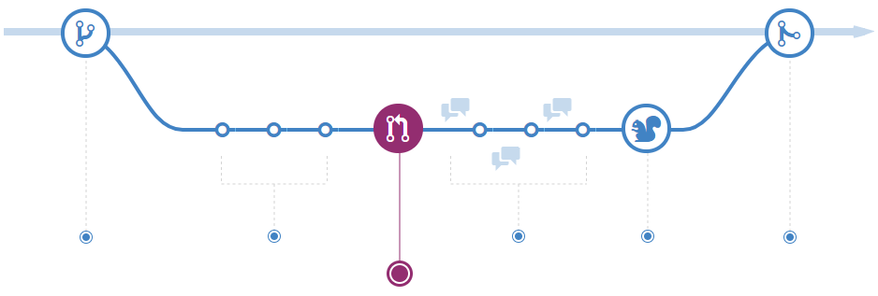

Request review and then do rework as required

## Finalize the changes

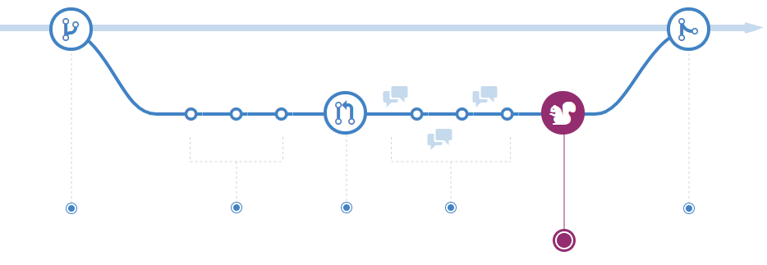

Complete review and rework until changes are all accepted.

## Merge to Trunk

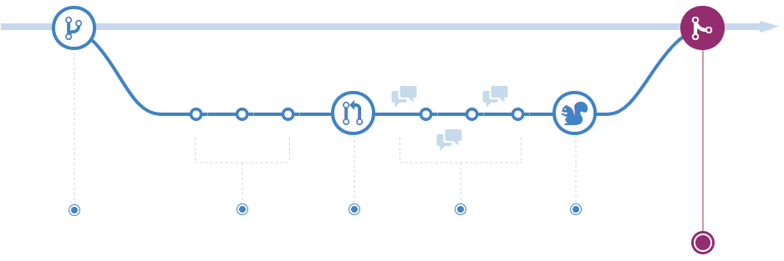

Merge the changes to trunk

* Must run maven build on all projects before sync up
* Request regression test (KOD551)

## Regression Test

Regression test is only required when there is trunk changes.

KOD551 is used for regression test.

* Successful – the process is completed.
* Failed
  + If it’s certain and quick fix (can be fixed within the day)
    - Fix on trunk, and then retest
  + Otherwise
    - Revert change being committed
    - Investigate and fix on branch following the process cycle again.